Movie Review Sentiment Analysis

Project Overview
This project is an NLP-based Sentiment Analysis system built using the IMDB 50K Movie Reviews dataset.
The application predicts whether a movie review is:
- Positive 😊
- Negative 😠
A Streamlit web application is also developed for real-time prediction.

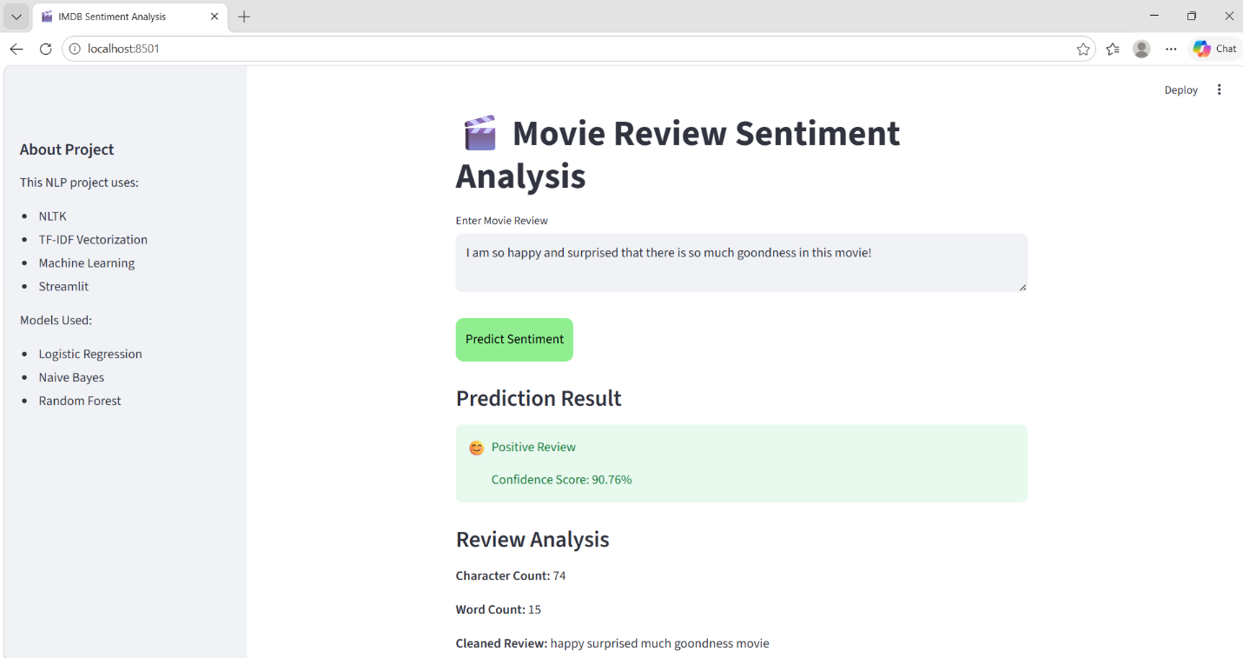

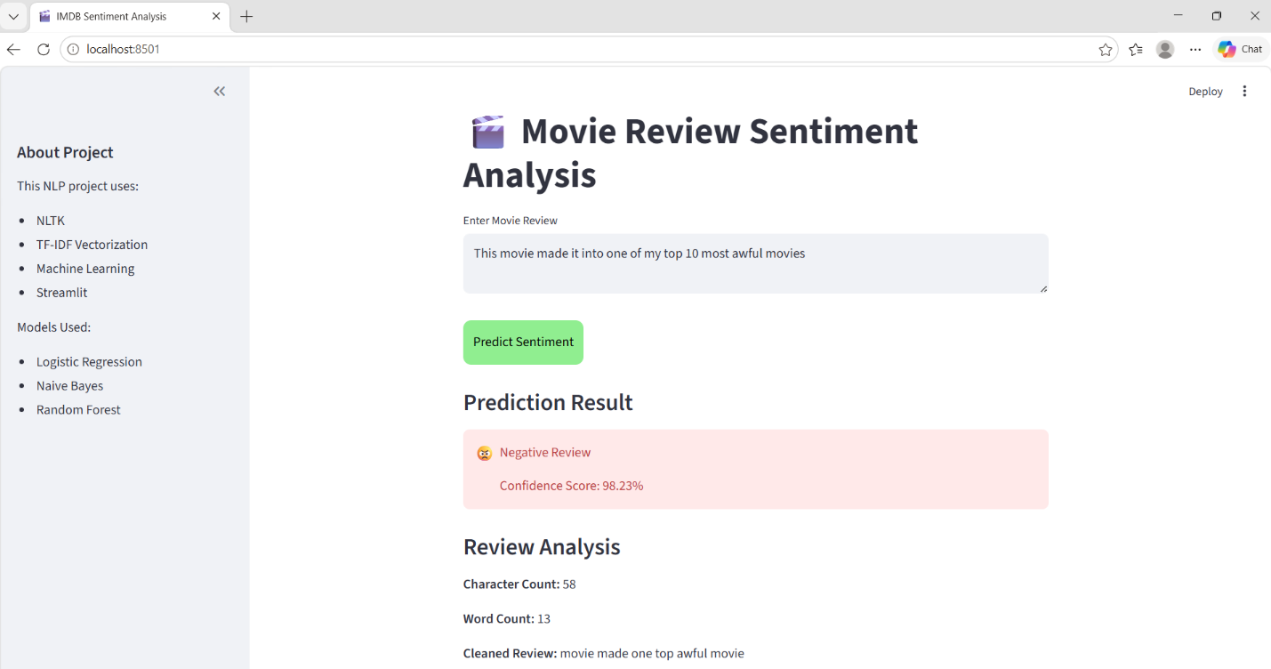

Technologies Used
- Python
- Pandas
- NumPy
- NLTK
- Scikit-learn
- Matplotlib
- Seaborn
- WordCloud
- Streamlit

Dataset
Dataset Link: https://www.kaggle.com/datasets/lakshmi25npathi/imdb-dataset-of-50k-movie-reviews/data
Dataset contains:
- 50,000 IMDB movie reviews
- Columns:
  - review
  - sentiment
Target variable:
- Positive
- Negative

Project Workflow

1. Data Loading
Dataset loaded using Pandas.

2. Exploratory Data Analysis (EDA)
Performed: - Sentiment distribution analysis - Word count analysis - Character count analysis - Frequent word analysis - Positive & Negative review visualization
Used: - Matplotlib - Seaborn

3. Text Preprocessing
Performed NLP preprocessing using NLTK:
- Lowercase conversion
- HTML tag removal
- URL removal
- Emoji removal
- Punctuation removal
- Stopword removal
- Tokenization
- Lemmatization
Purpose: - Clean noisy text - Improve model performance

NLP Techniques Used

Tokenization
Splits sentences into words.

Stopword Removal
Removes common unnecessary words.

Lemmatization
Converts words into root form.

Bag of Words (BoW)
Converts text into numerical vectors.

TF-IDF
Gives importance score for meaningful words.

Visualizations
Created: - Count plots - Histograms - Boxplots - Word Frequency Charts - Positive WordCloud - Negative WordCloud - Bigram Analysis

Machine Learning Models Used
- Logistic Regression
- Naive Bayes
- Random Forest
Compared model accuracy and selected best-performing model.

Evaluation Metrics
Used: - Accuracy Score - Confusion Matrix - Classification Report

Model Saving
Saved: - Trained ML model - TF-IDF Vectorizer
Using: - Joblib

Streamlit Web App
Features: - User review input - Real-time sentiment prediction - Confidence percentage - Review analysis - Interactive UI

